Game Center Test Manual

# Overview

The following testing was created for the Game Center v 3.5 beta application. Since this application relies heavily on the GUI interface, screenshots prior to and after testing functions. All primary functions of the application have been tested thoroughly for functionality. Several bugs are known about prior to the writing of this test document. The known bugs are listed at the end of the document.

# Account

The following section outlines the account creation function. For this the following data was used:

First Name: Greg

Last Name: Volpe

Email: volpe@gmail.com

GamerTag: volpe4

Password 1: qwerty

Password 2: qwerty

## Account Creation

For the first test, the First Name field was intentionally left blank to show the error checking that takes place within the application.

Test 1: Results:

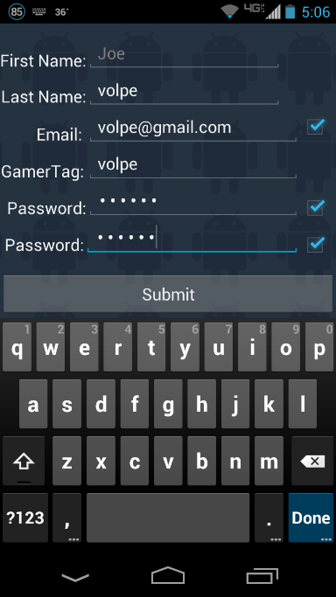 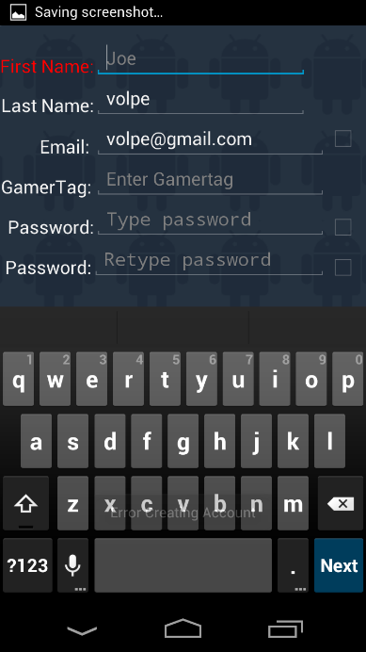

Results are as expected, the missing field is highlighted and a notification is posted to the bottom of the screen. In addition when entering the information checkmarks appeared on the Email field, Password 1, and Password 2 fields when entered correctly.

In the next test, the GamerTag is set to Volptar88, which is already in use:

Test 2: Results:

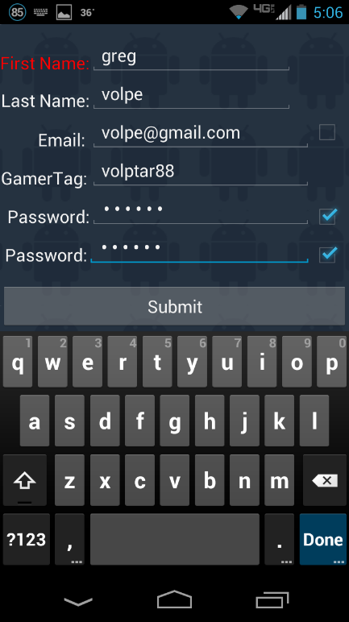 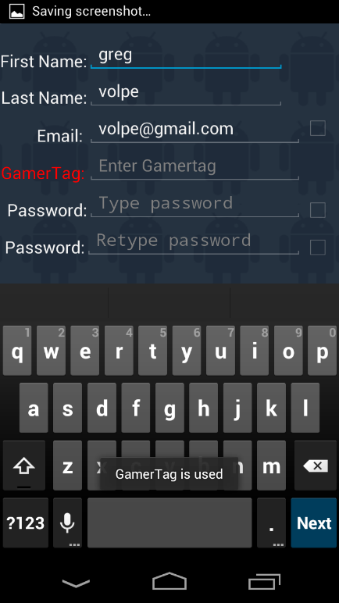

Results of this test are as expected; The GamerTag field becomes highlighted and account creation is denied. A notification is posted to the bottom of the screen identifiying the error.

In the next test, all input is correctly entered:

Test 3: Results:

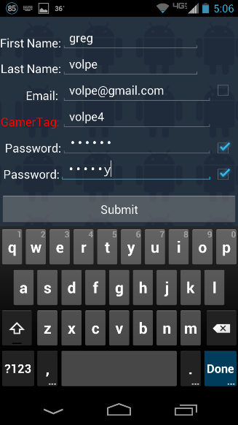 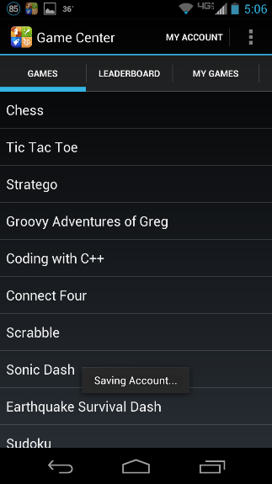 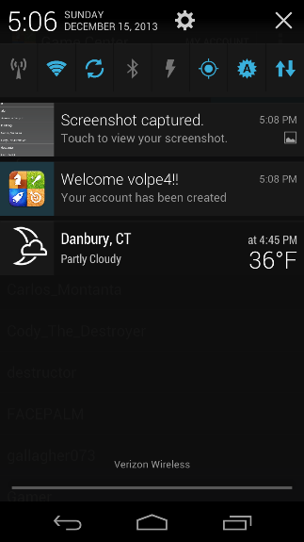

Results are as expected; Account is successfully created and the All Games tab is displayed. A notification at the bottom of the screen tells the user that the account has been saved to the local storage on the phone, for easier access. A notification is placed in the system notification tray welcoming the user to the application, and signaling successful account creation.

# My Games Tab

The My Games tab is tested directly after account creation by clicking on the My Games tab. The expectations of this test are that no games will be listed in the Game list.

Results:

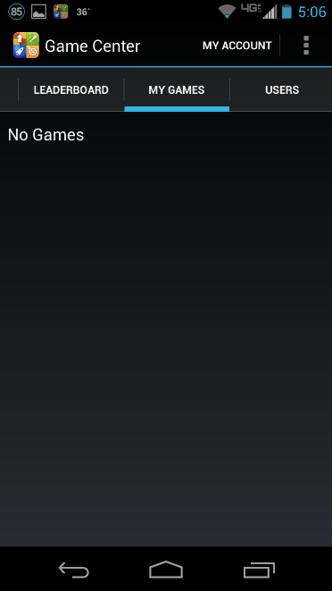The results of this test are as expected. After clicking on the My Games tab, the view is inflated. No games are listed in the My Games tab.

Note: There have been circumstances where games from previous accounts that are logged in have shown up on the initial click of the My Games tab. This exception only holds true for the first time the tab is clicked. Once the user navigates to a different tab, and then reselects the My Games tab, the true results are drawn to the screen.

# Game Installation

## Test Installation

The next test two games are selected for installation, Chess and Stratego.

Test Result

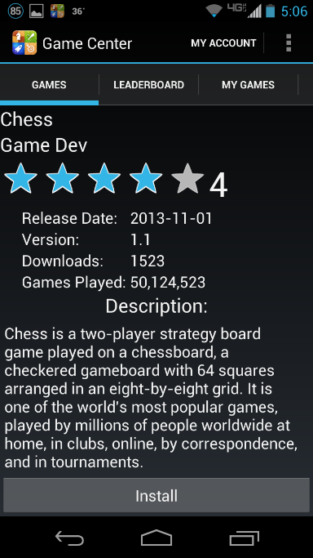 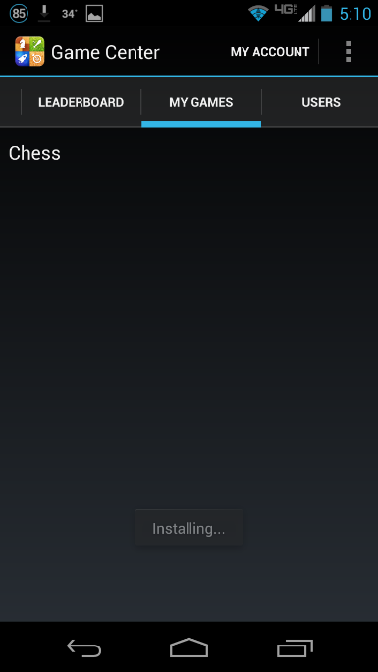

The results of this test are as expected. The Chess game is now listed under the My Games tab. In addition, a connection is made to the server and the Chess.apk file is downloaded onto the phone in the default download directory.

## Test Installation 2

Test: Result

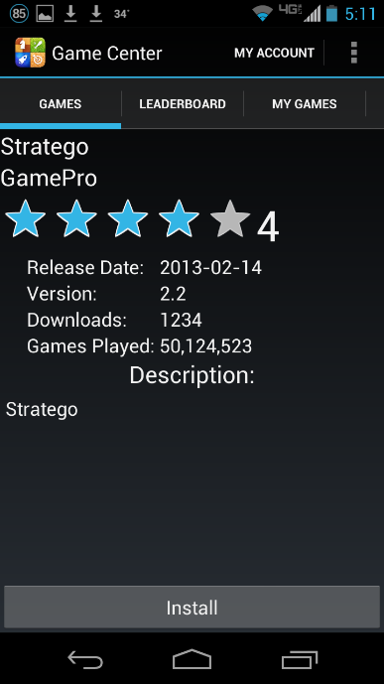 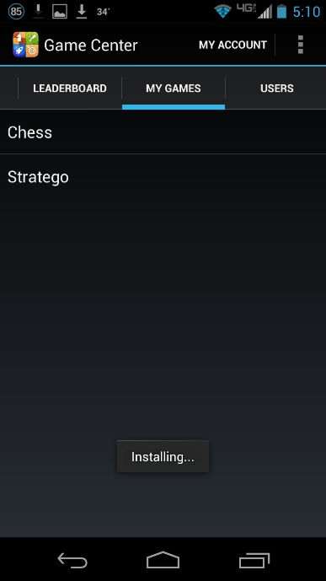

The results are as expected; Stratego is now listed under the My Games tab and connection is made to the server and the apk is downloaded into the default directory on the device.

# Leaderboard

## Leaderboard List Page

This test shows the Leaderboard Tab, when clicked it will display a list of games in the system.

Results:

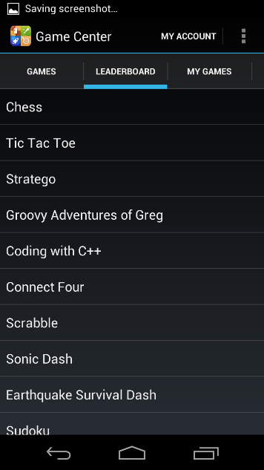The results for this test are as expected, a list of game names is displayed. This list exactly matches the list of games on the Games tab. Clicking any one of these games will display the Leaderboard list.

## Game Leaderboard Page

In the next test, the game Stratego is selected to view the list of top players. This test took place after the Stratego Game had been downloaded to the phone and added to the users account.

Test: Results:

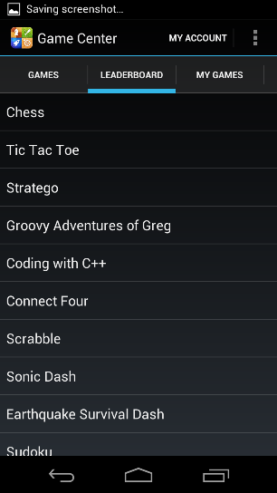 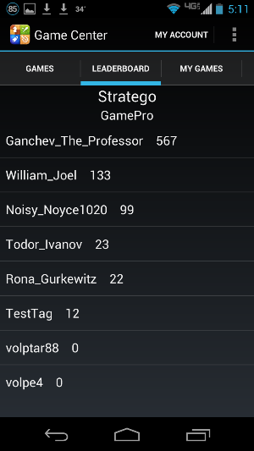

The results of this test are as expected; the Stratego leaderboard is displayed. The user volpe4 (current users account) has been added to the Leaderboard list. Since there are currently less than 10 players with the Statego Game, all GamerTags are displayed in the list.

# Users Tab

The expected output for the users tab is a list of all users in the system.

Results:

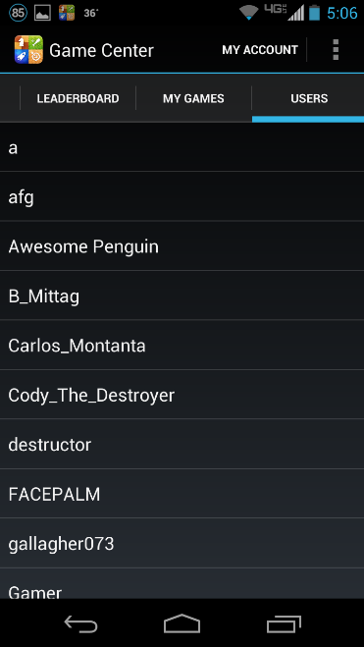The results are as expected. A list showing all users is displayed. The results of this list are not clickable.

# My Account

## Account Display Page

The My Account page should display the GamerTag, First Name, Last Name, and Email Address. There should also be a button available to update the account information.

Results:

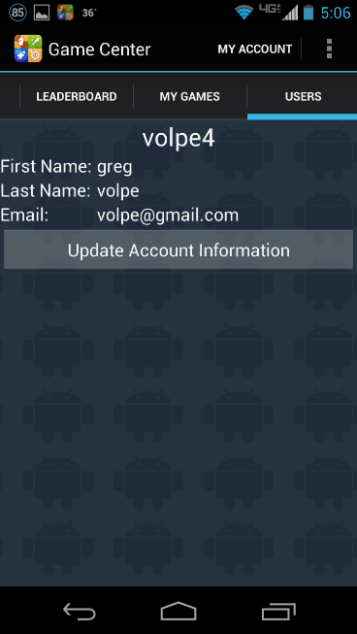The My Account page is displayed as expected. All fields are filled with the proper information, and the Update Account Information button is populated in the correct spot.

## Account Update

Clicking the Update Account Information button should create a new page to edit the account information. This page is a modified version of the Fill Data page used for account creation. Since the pages are the same, the constraints previously tested in the account creation test will not be tested during this test although they are still functioning for this page as well. The purpose of this test is to show that the GamerTag field is not modifiable, and that any changes made to the account names, email address, or password will be saved in the database.

For this test, the following new information will be used First Name: Gregory and Email: volpe1988@gmail.com. The Last Name will be filled in from current account information and the password entered will be the same as what is currently in the database.

Test: Results:

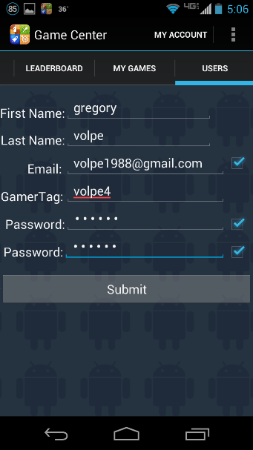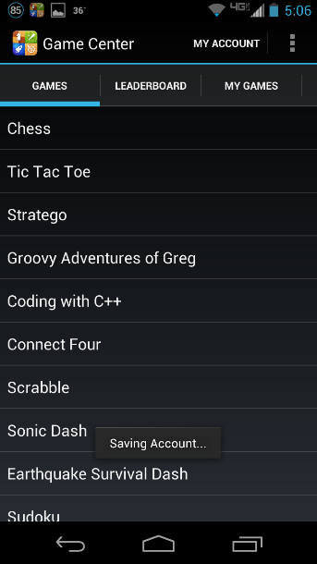 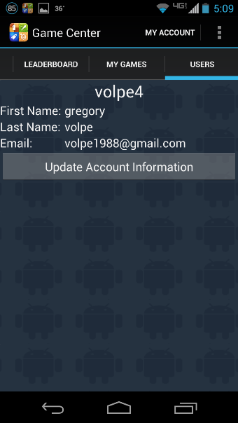

Database entry post update:



The results of this test are as expected; the account was created successfully and the All Games tab is automatically drawn on the screen and a notification is placed at the bottom to signal successful account creation. A notification is also placed in the system notification tray. After navigating back to the My Account page, the data displayed is the new information. For verification the database entry was checked and displayed the correct results.

# Game Uninstallation

## Game Uninstallation Test 1

This test demonstrates the ability to uninstall a game. For this test, the only game installed is Chess and will be uninstalled. In order to initiate an uninstall of the game, the uninstall button must be selected.

Test 1: Results:

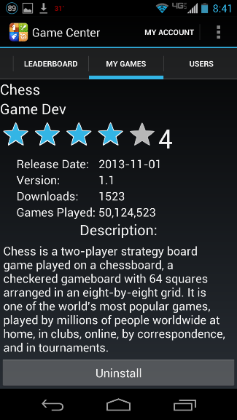 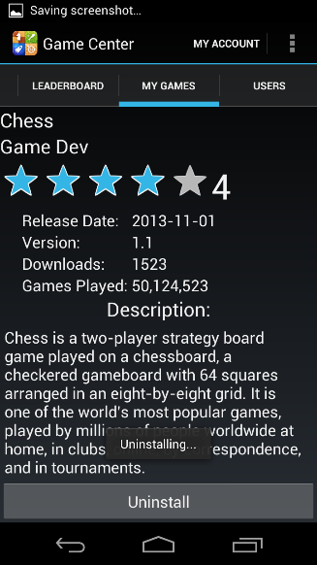 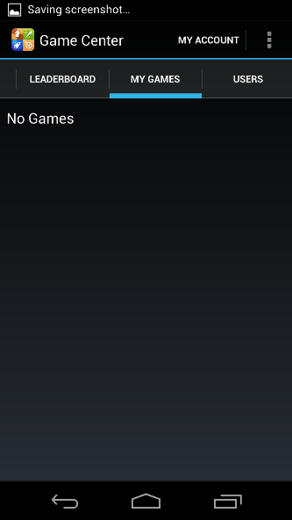 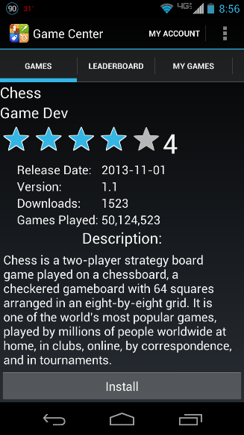

The results of this test are as expected. After first pressing the uninstall button the program notifies the user that the uninstallation process is taking place. When navigating back to the My Games tab, there are no games that are currently installed on the device. When navigating to the All Games tab, and selecting the Chess game, the button is now marked as an install button.

In addition, the apk file is deleted from the phones default download directory. This image shows the directory after the uninstall process and shows that there are no items in the directory.

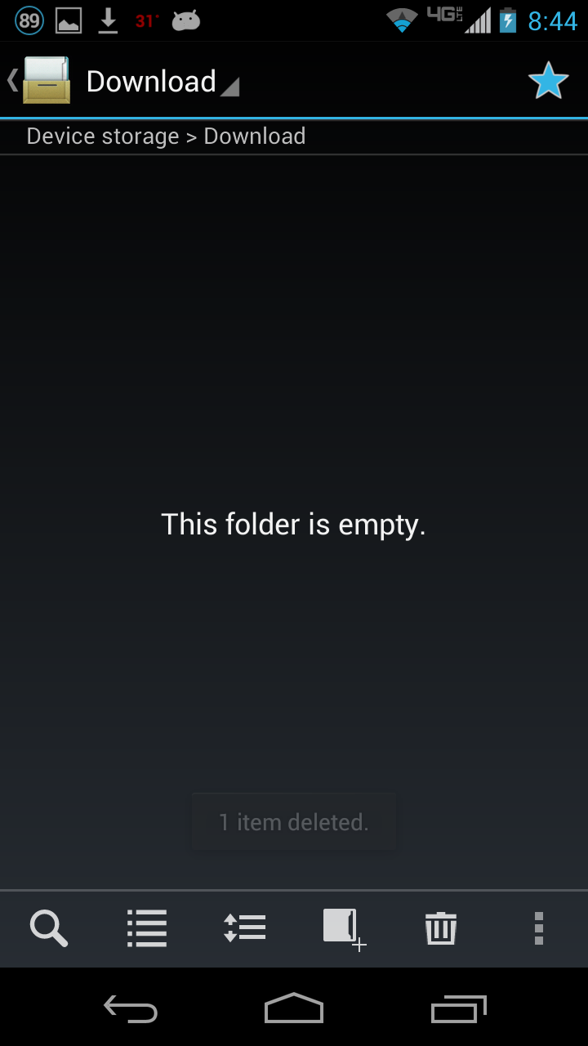

NOTE: When using install / uninstall on an Android Virtual Device, the directory that the apk files download to are unavailable. This testing took place on an actual android device. Workarounds are in place so that the process is simulated on and AVD.